# IPB1 29b core RUN summary

Jin Liu

11/1/2016

We have done two helium and two h2 runs on IPB1 29 core. This note is the summary of four runs. Table 1 through Table 4 list four runs data; and Figure 1 through Figure 4 are the time series of four runs, and Figure 5 through Figure 8 are the mean of each sequence with the standard deviation as the error bars for “Heater Power”. Note: Run3 has no valid coreQPower data, we replace them from Run4. The “Blank” in the tables means no valid data has been retrieved.

Two COP calculations have been applied here. The formulas are the below:

[1] “Calorimetry of the IPB System” 9/2/2016

[2] “IPB Reactor Calibration, for discussion purpose only” 11/2/2016

1. COP = (HP drop + m * coreQPower*correctFactor + b) / (coreQPower*correctFactor)
2. COP = (HP drop +kas*(Ta-Ts) +kbs*(Tb-Ts))/coreQPower

Where HP drop is Heater Power (No QPulse)-Heater Powe r(with QPulse)

coreQPower is Q Pulse power deposited to the core.

correctFactor is determined by calibrating COP to approximately 1.0 with helium runs.

kas and kbs are determined by calibrating COP to approximately 1.0 with helium runs

Ta is core temperature

Ts is surrounding temperature (outer block temperature)

Tb is inner block temperature

Table 5 & Table 6 are COP results of four runs from formula 1.

Table 7 & Table 8 are COP results of four runs from formula 2.

Table 1. Run1, 10/4/2016-10/6/2016 He

|  |  |  |  |  |  |  |  |  |  |  |  |
| --- | --- | --- | --- | --- | --- | --- | --- | --- | --- | --- | --- |
|  | Heater Power(W) | | | | | | coreQPower(W) | | | | |
| QpulseWidth(ns) | NQ | 300 | 150 | 100 | 150 | 300 | 300 | 150 | 100 | 150 | 300 |
| Temp |  | | | | | |  | | | | |
| 150 | 9.40 | 6.94 | 6.70 | 6.71 | 6.67 | 6.69 | 4.93 | 5.08 | 5.28 | 5.08 | 4.92 |
| 200 | 14.00 | 11.11 | 10.92 | 10.84 | 10.82 | 10.82 | 5.24 | 5.43 | 5.64 | 5.42 | 5.25 |
| 250 | 19.11 | 15.57 | 15.23 | 15.15 | 15.18 | 15.34 | 5.28 | 5.87 | 6.10 | 5.86 | 5.62 |
| 300 | 24.86 | 20.75 | 20.28 | 19.91 | 20.20 | 20.50 | 5.08 | 6.29 | 6.36 | 6.11 | 5.70 |
| 350 | 31.25 | 26.97 | 26.84 | 26.77 | 26.76 | 26.66 | 4.92 | 6.20 | 6.35 | 6.18 | 5.93 |
| 400 | 38.26 | 33.75 | 33.81 | 33.58 | 33.78 | 33.48 | 6.16 | 6.32 | 6.39 | 6.31 | 6.14 |

Table 2. Run2, 10/19/2016-10/20/2016 He

|  |  |  |  |  |  |  |  |  |  |  |  |
| --- | --- | --- | --- | --- | --- | --- | --- | --- | --- | --- | --- |
|  | Heater Power(W) | | | | | | coreQPower(W) | | | | |
| QpulseWidth(ns) | NQ | 300 | 150 | 100 | 150 | 300 | 300 | 150 | 100 | 150 | 300 |
| Temp |  | | | | | |  | | | | |
| 150 | 9.48 | 7.03 | 6.88 | 6.93 | 6.89 | 6.77 | 5.14 | 5.13 | 5.22 | 5.13 | 5.16 |
| 200 | 14.08 | 11.17 | 11.00 | 11.09 | 11.05 | 10.96 | 5.51 | 5.48 | 5.58 | 5.48 | 5.52 |
| 250 | 19.17 | 15.74 | 15.47 | 15.36 | 15.33 | 15.49 | 5.93 | 5.94 | 6.11 | 5.95 | 5.93 |
| 300 | 24.86 | 20.71 | 20.29 | 20.25 | 20.46 | 20.59 |  |  | 6.64 | 6.44 | 6.36 |
| 350 | 31.31 | 28.07 | 27.41 | 26.96 | 26.87 | 26.80 | 5.75 | 6.47 | 6.54 | 6.47 | 6.58 |
| 400 | 38.32 | 33.77 | 33.84 | 34.05 | 33.81 | 33.56 | 6.82 | 6.58 | 6.55 | 6.60 | 6.83 |

Table 3. Run3, 10/27/2016-10/28/2016 H2

|  |  |  |  |  |  |  |  |
| --- | --- | --- | --- | --- | --- | --- | --- |
|  | Heater Power(W) | | | | coreQPower(W) | | |
| QpulseWidth(ns) | NQ | 150 | 100 | 150 | 150 | 100 | 150 |
| Temp |  |  |  |  |  |  |  |
| 9.40 | 7.58 | 7.58 | 7.26 | 7.43 | 2.66 | 3.06 | 2.66 |
| 14.17 | 11.87 | 11.87 | 11.56 | 11.76 | 2.88 | 3.26 | 2.87 |
| 19.36 | 16.48 | 16.48 | 16.17 | 16.37 | 3.18 | 3.59 | 3.18 |
| 25.19 | 21.51 | 21.51 | 21.11 | 21.44 | 3.57 | 4.03 | 3.56 |

Table 4. Run4, 10/29/2016-10/31/2016 H2

|  |  |  |  |  |  |  |  |
| --- | --- | --- | --- | --- | --- | --- | --- |
|  | Heater Power(W) | | | | coreQPower(W) | | |
| QpulseWidth(ns) | NQ | 150 | 100 | 150 | 150 | 100 | 150 |
| Temp |  |  |  |  |  |  |  |
| 150 | 9.49 | 7.45 | 7.38 | 7.37 | 2.66 | 3.06 | 2.66 |
| 200 | 14.17 | 11.76 | 11.65 | 11.58 | 2.88 | 3.26 | 2.87 |
| 250 | 19.37 | 16.28 | 16.40 | 16.27 | 3.18 | 3.59 | 3.18 |
| 300 | 25.20 | 21.30 | 21.15 | 21.17 | 3.57 | 4.03 | 3.56 |
| 350 | 31.71 | 28.20 | 28.10 | 28.00 | 3.45 | 3.86 | 3.44 |
| 400 | 38.92 | 35.53 | 35.73 |  | 3.40 | 3.68 |  |

Table 5. Run1 & Run2, COP (1)

|  |  |  |  |  |  |  |  |  |  |  |  |
| --- | --- | --- | --- | --- | --- | --- | --- | --- | --- | --- | --- |
| QpulseWidth(ns) | CorrectFactor | 300 | 150 | 100 | 150 | 300 | 300 | 150 | 100 | 150 | 300 |
| Temp |  | Run1:COP | | | | | Run2:COP | | | | |
| 150 | 1.00 | 0.99 | 1.02 | 1.00 | 1.03 | 1.04 | 0.97 | 1.00 | 0.98 | 1.00 | 1.02 |
| 200 | 1.10 | 1.02 | 1.04 | 1.03 | 1.06 | 1.08 | 1.00 | 1.03 | 1.01 | 1.03 | 1.04 |
| 250 | 1.30 | 1.06 | 1.05 | 1.04 | 1.06 | 1.06 | 0.99 | 1.02 | 1.02 | 1.04 | 1.02 |
| 300 | 1.50 | 1.11 | 1.05 | 1.08 | 1.08 | 1.08 |  |  | 1.03 | 1.02 | 1.01 |
| 350 | 1.50 | 1.15 | 1.05 | 1.04 | 1.06 | 1.09 | 0.95 | 0.98 | 1.02 | 1.03 | 1.03 |
| 400 | 1.60 | 1.06 | 1.05 | 1.06 | 1.05 | 1.09 | 1.02 | 1.03 | 1.01 | 1.03 | 1.04 |

Table 6. Run3 & Run4, COP (1)

|  |  |  |  |  |  |  |  |
| --- | --- | --- | --- | --- | --- | --- | --- |
| QpulseWidth(ns) | CorrectFactor | 150 | 100 | 150 | 150 | 100 | 150 |
|  |  | Run3:COP | | | Run4:COP | | |
| 150 | 1.00 | 1.15 | 1.16 | 1.20 | 1.23 | 1.15 | 1.26 |
| 200 | 1.10 | 1.20 | 1.20 | 1.24 | 1.23 | 1.17 | 1.29 |
| 250 | 1.30 | 1.20 | 1.19 | 1.23 | 1.25 | 1.14 | 1.25 |
| 300 | 1.50 | 1.22 | 1.21 | 1.23 | 1.26 | 1.20 | 1.29 |
| 350 | 1.50 |  |  |  | 1.25 | 1.19 | 1.29 |
| 400 | 1.60 |  |  |  | 1.19 | 1.11 |  |

Table 7. Run1 & Run2, COP (2)

|  |  |  |  |  |  |  |  |  |  |  |  |
| --- | --- | --- | --- | --- | --- | --- | --- | --- | --- | --- | --- |
| QpulseWidth(ns) | kas/ kbs | 300 | 150 | 100 | 150 | 300 | 300 | 150 | 100 | 150 | 300 |
| Temp |  | Run1:COP | | | | | Run2:COP | | | | |
| 150 | 0.0100 | 1.00 | 1.01 | 0.96 | 1.02 | 1.05 | 0.96 | 0.98 | 0.96 | 0.98 | 1.00 |
| 200 | 0.0070 | 1.01 | 1.00 | 0.97 | 1.02 | 1.06 | 0.97 | 1.00 | 0.97 | 1.00 | 0.99 |
| 250 | 0.0046 | 1.00 | 1.00 | 0.98 | 0.99 | 1.03 | 0.92 | 0.96 | 0.95 | 0.99 | 0.97 |
| 300 | 0.0030 | 0.95 | 0.98 | 1.00 | 1.01 | 1.05 |  | 0.96 | 0.94 | 0.92 | 0.92 |
| 350 | 0.0030 | 1.05 | 1.01 | 1.01 | 1.04 | 1.09 |  | 0.92 | 0.96 | 0.98 | 0.98 |
| 400 | 0.0030 | 1.10 | 1.06 | 1.07 |  | 1.13 | 0.99 | 1.00 | 0.99 | 1.01 | 1.01 |

Table 8. Run3 & Run4, COP (2)

|  |  |  |  |  |  |  |  |
| --- | --- | --- | --- | --- | --- | --- | --- |
| QpulseWidth(ns) | kas/ kbs | 150 | 100 | 150 | 150 | 100 | 150 |
|  |  | Run3:COP | | | Run4:COP | | |
| 150 | 0.0100 | 1.59 | 1.49 | 1.65 | 1.68 | 1.48 | 1.71 |
| 200 | 0.0070 | 1.62 | 1.53 | 1.67 | 1.66 | 1.50 | 1.73 |
| 250 | 0.0046 | 1.54 | 1.44 | 1.57 | 1.60 | 1.38 | 1.60 |
| 300 | 0.0030 | 1.48 | 1.41 | 1.50 | 1.54 | 1.40 | 1.58 |
| 350 | 0.0030 |  |  |  | 1.57 | 1.43 | 1.62 |
| 400 | 0.0030 |  |  |  | 1.63 | 1.46 |  |

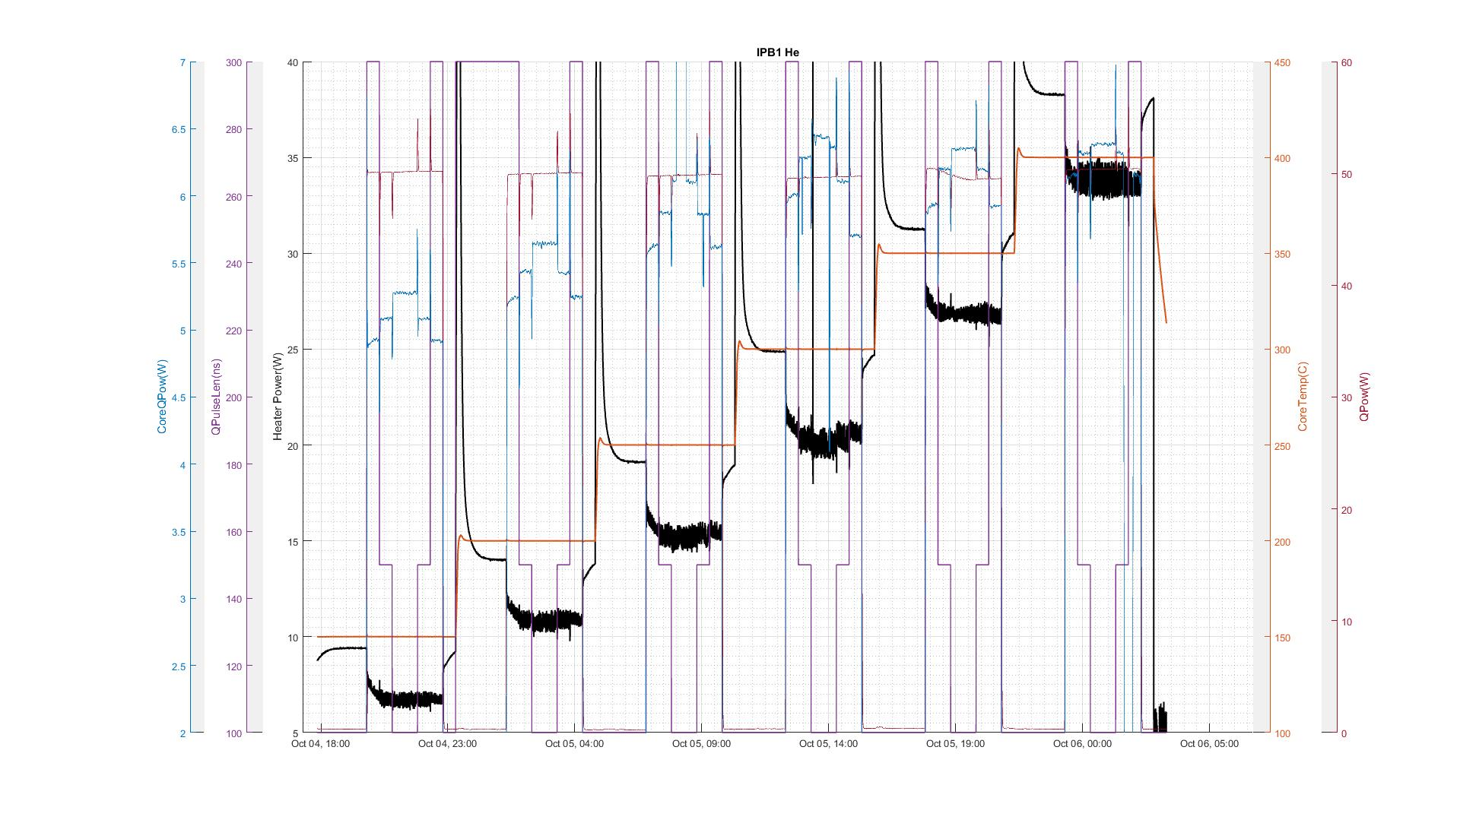

Figure 1. Run1 He 10/04/2016

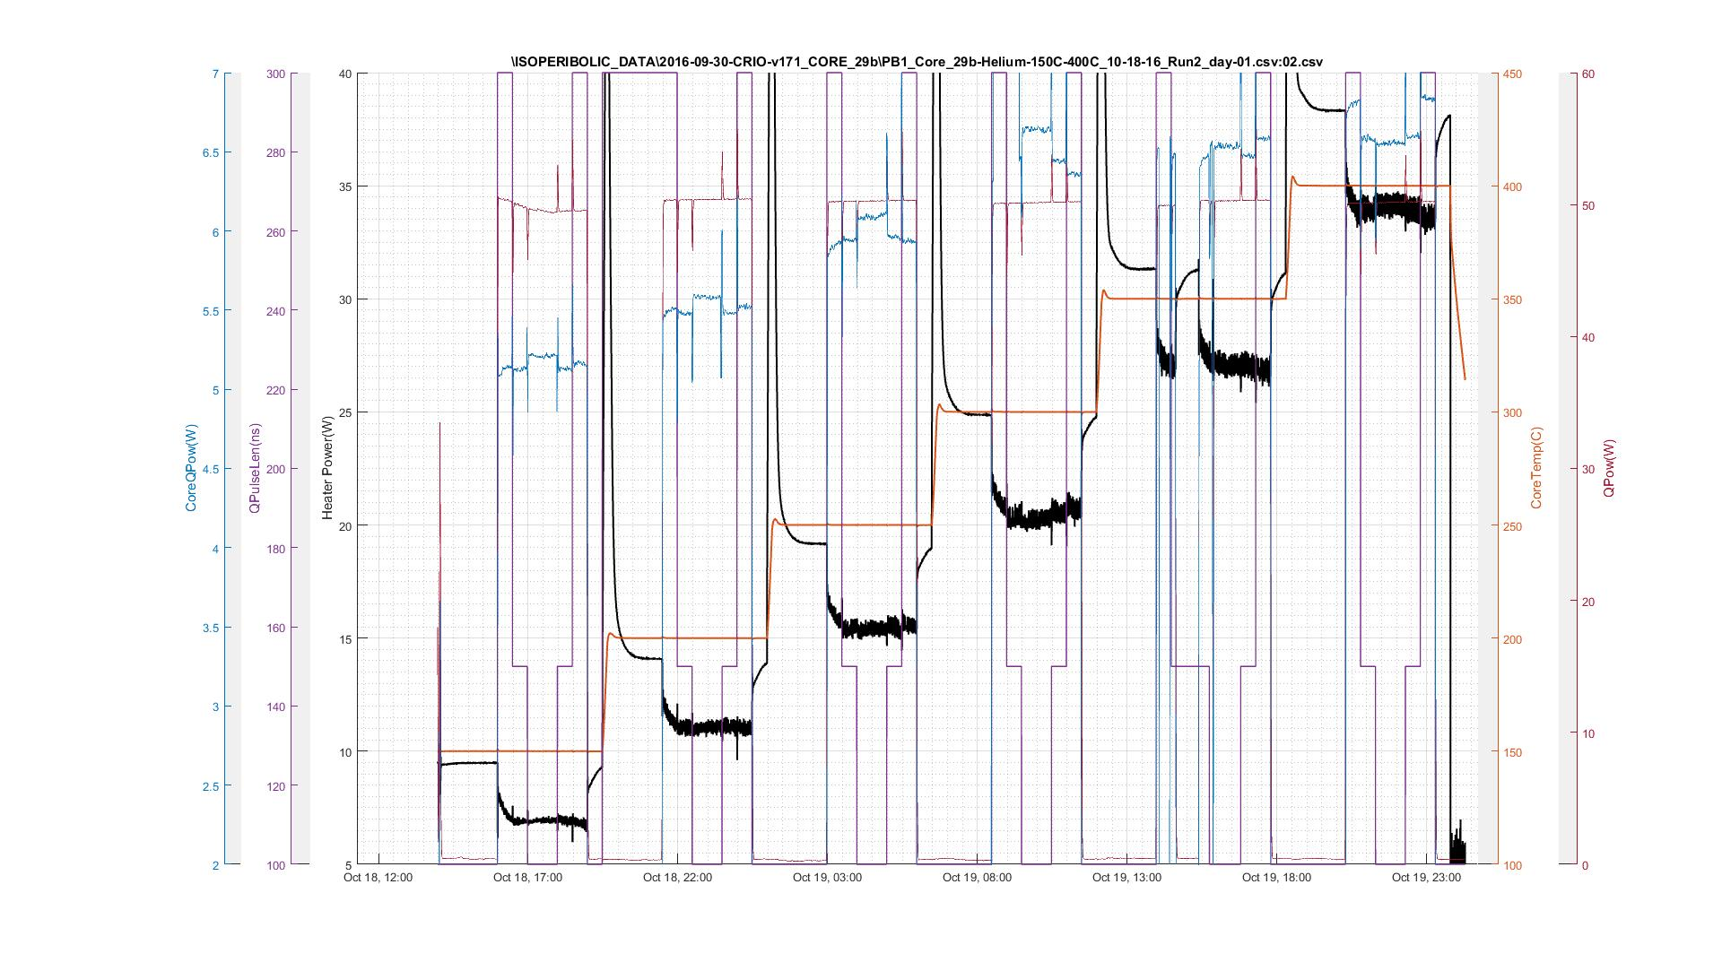

Figure 2. Run2 He 10/18/2016

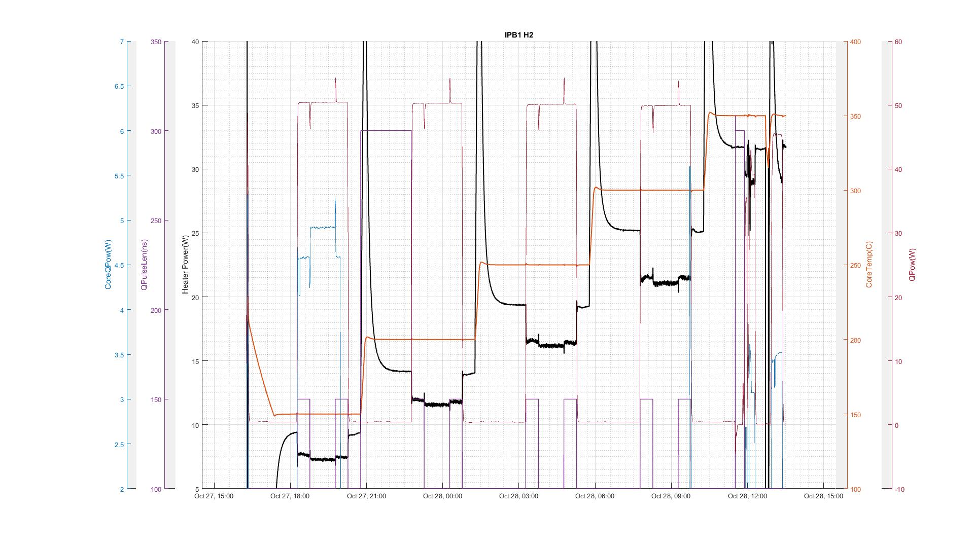

Figure 3. Run3 H2 10/27/2016

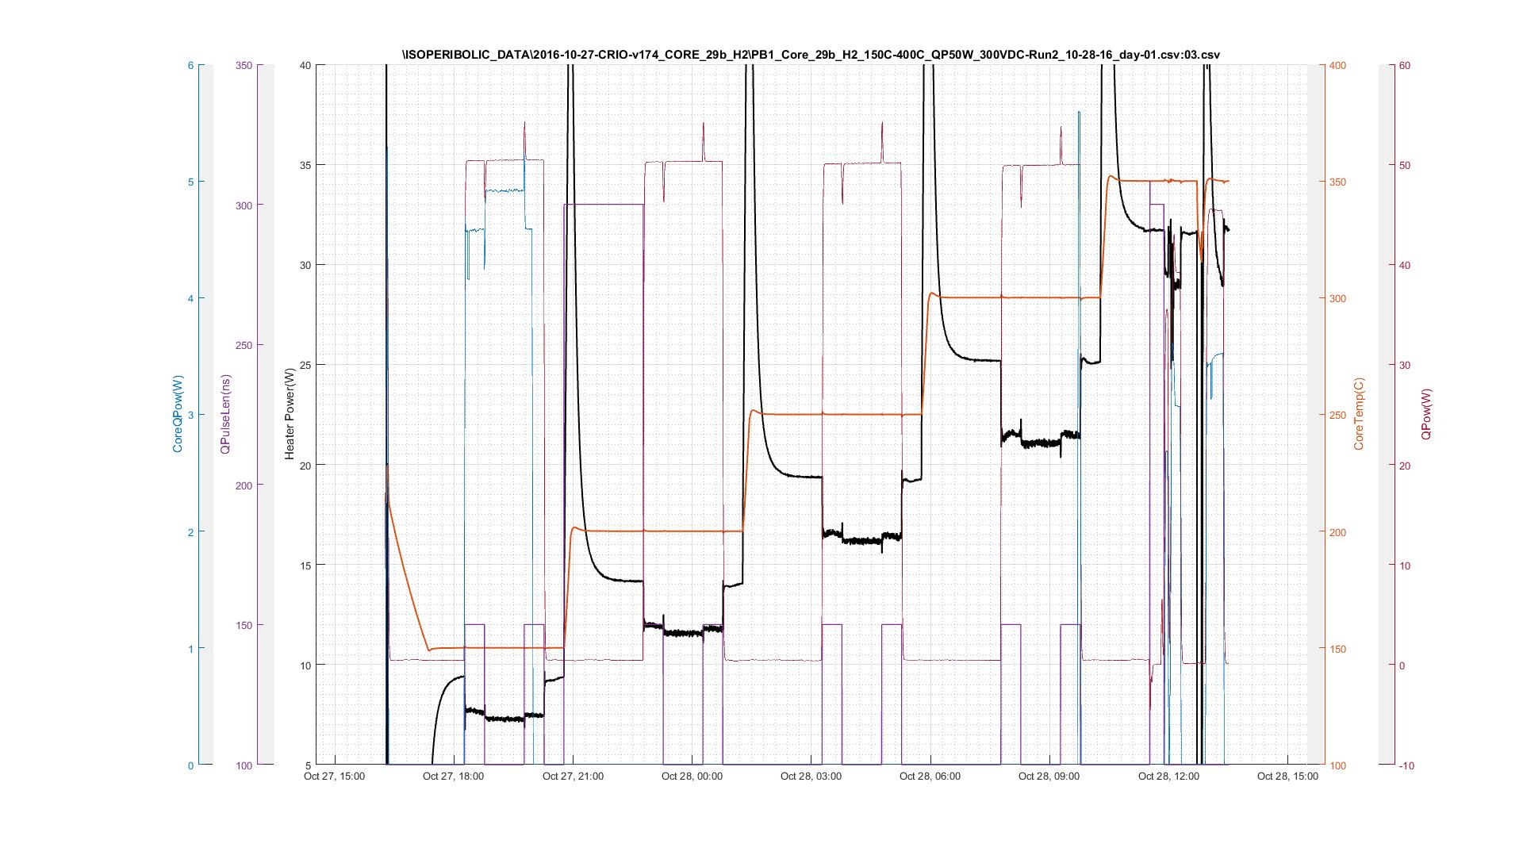

Figure 4. Run4 H2 10/28/2016

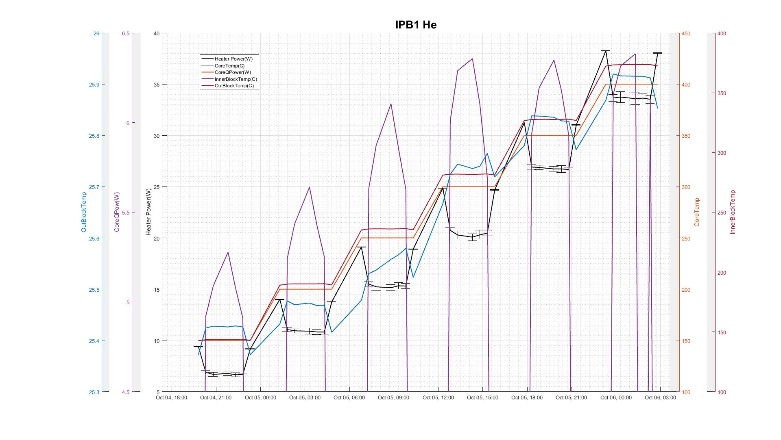

Figure 5. Run1 He with error bar of heater power 10/4/2016

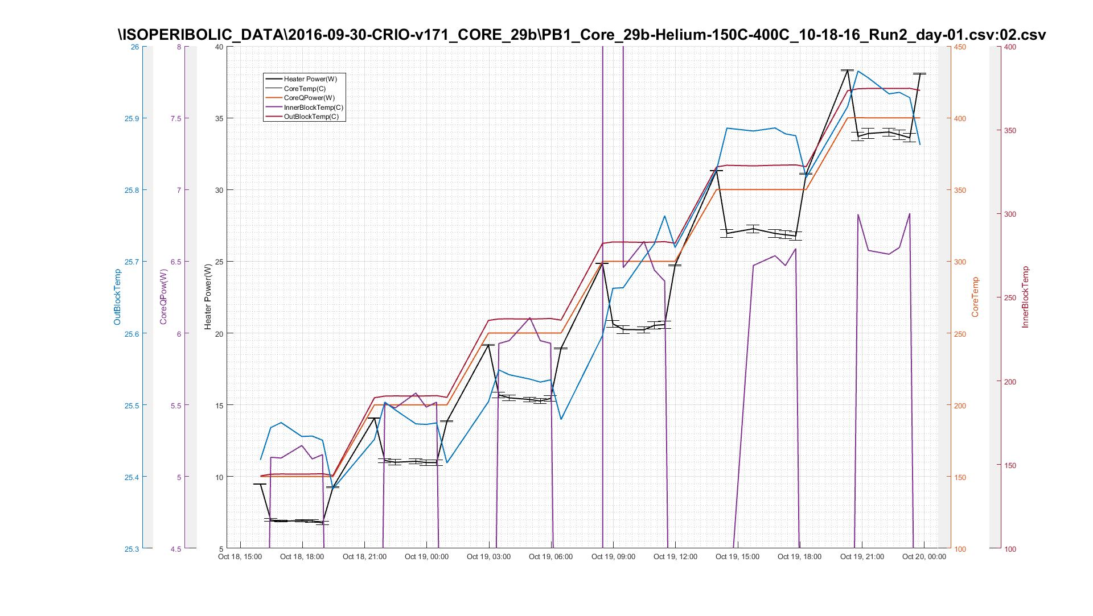

Figure 6. Run2 He with error bar of heater power 10/18/2016

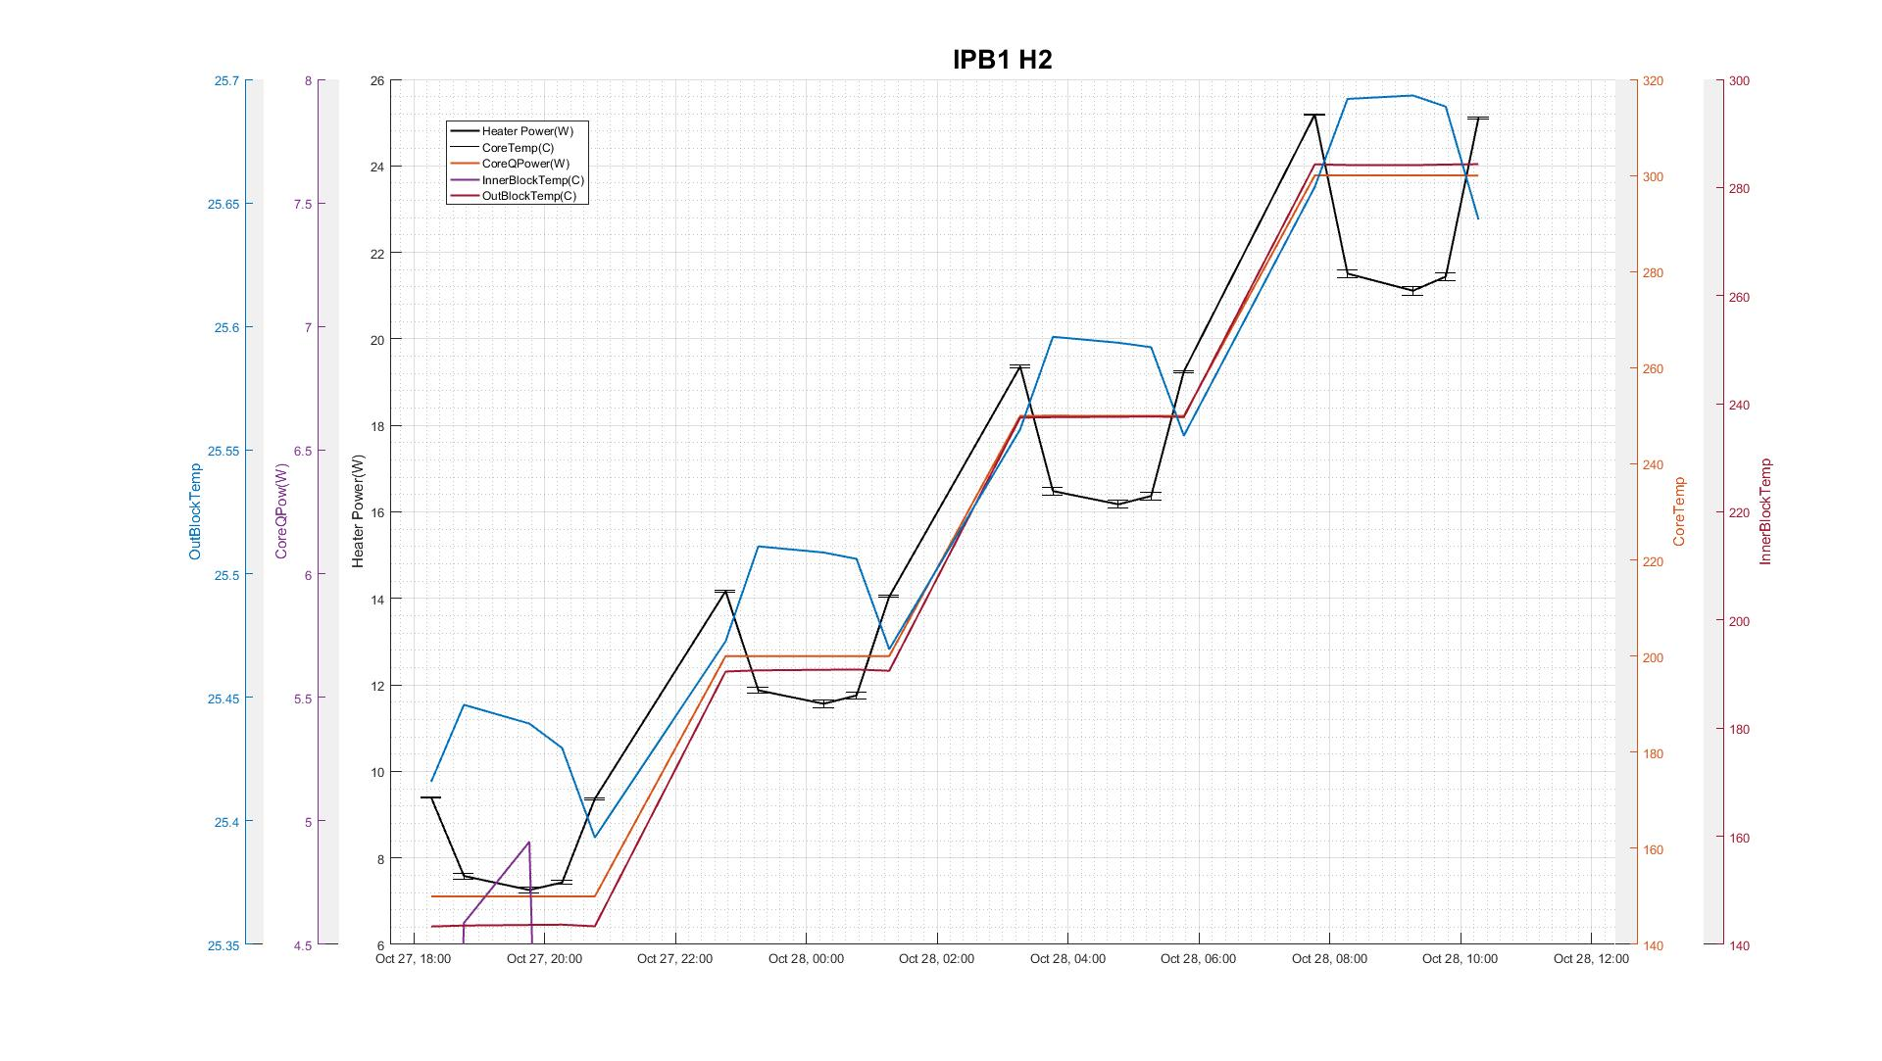

Figure 7. Run3 H2 with error bar of heater power 10/27/2016

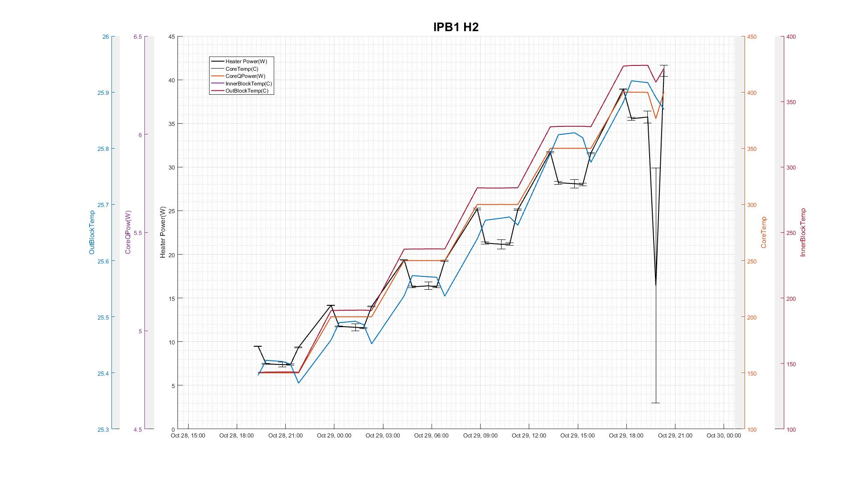

Figure 8. Run4 H2 with error bar of heater power 10/28/2016